Project Development Phase

|  |  |
| --- | --- |
| Team ID | PNT2022TMID41669 |
| Project Name | **IoT Based Safety Gadget for Child Safety Monitoring and Notification** |
| Maximum Marks | 8 Marks |

SPRINT II:- SIGN UP PAGE AND HOME PAGE:

**Link:** http://127.0.0.1:1880/#flow/bc9656fd4e922200

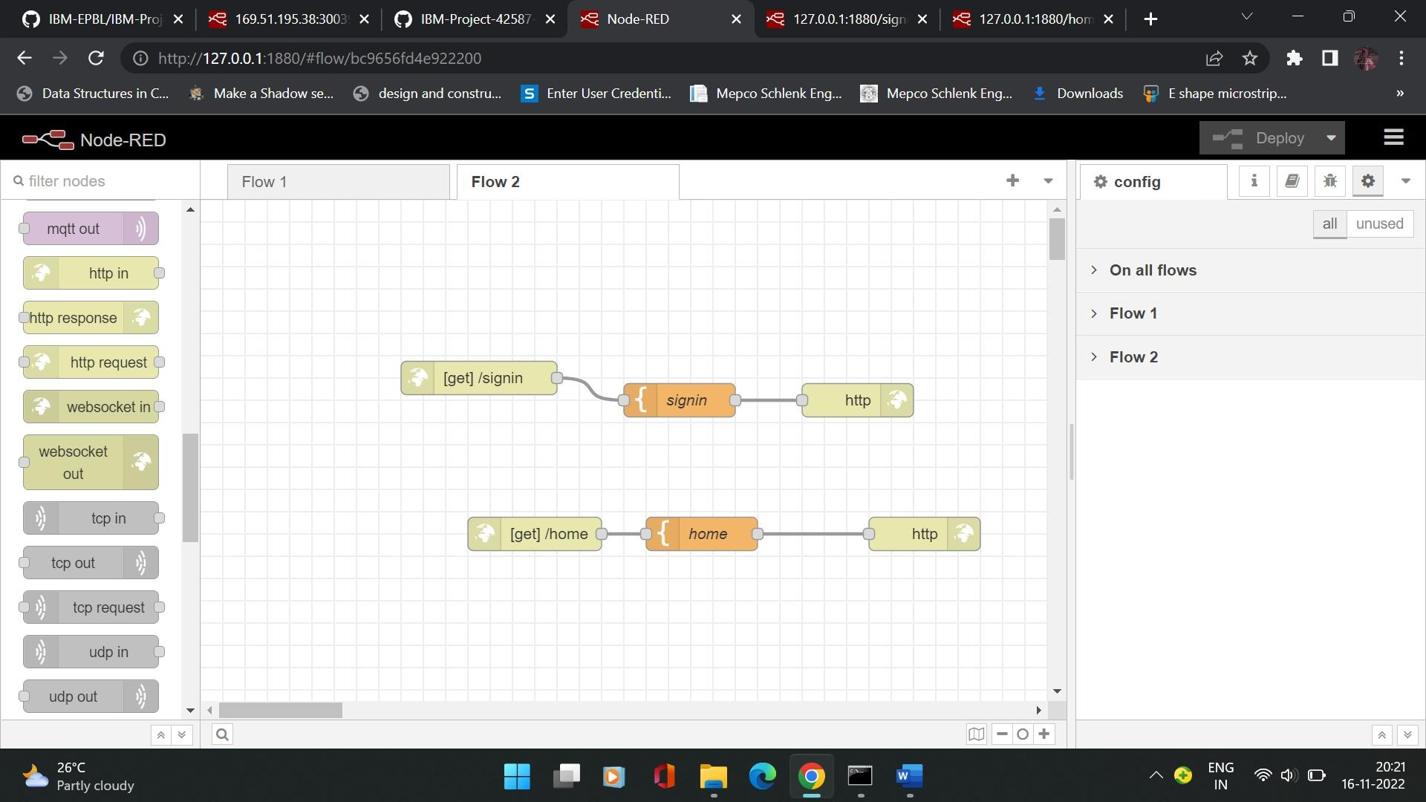

SIGN IN PAGE:

Link: http://127.0.0.1:1880/signin

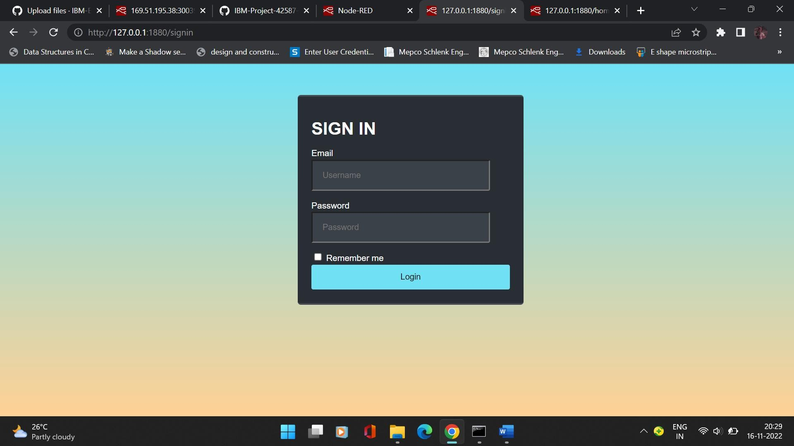

HOME PAGE:

LINK: http://127.0.0.1:1880/home

